Best Remote Job Boards to Find Remote Work 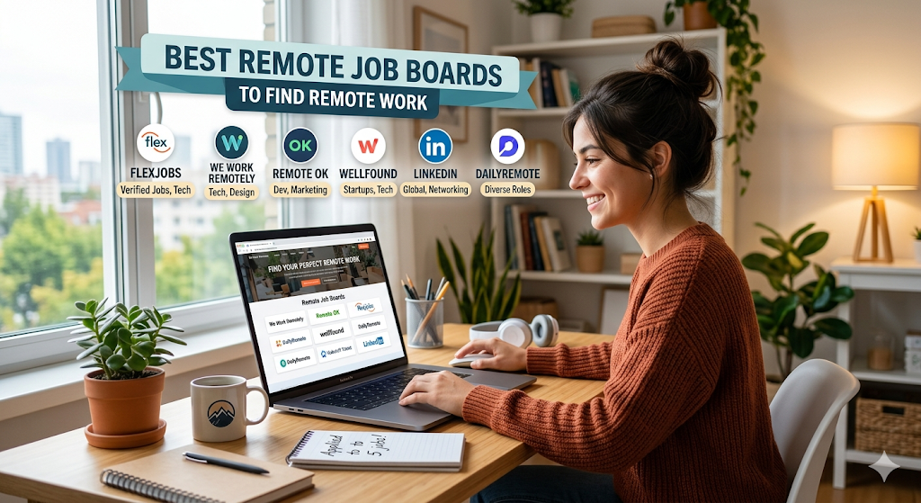
Finding the best remote job boards
has become essential for professionals who want more flexibility, better work-life balance, and access to global career opportunities in 2026.
Remote work is no longer limited to freelancers or tech workers.
Today, companies worldwide are hiring for:
- remote jobs
- work from home jobs
- Hybrid roles
- Global freelance contracts
- International virtual positions
across industries like:
- Technology
- Marketing
- Customer support
- Design
- Finance
- Education
According to LinkedIn, remote and hybrid work opportunities continue growing as companies increasingly adopt:
- Flexible work policies
- Global hiring
- Distributed workforce models
This guide explains:
- The best job boards for remote work
- Top remote hiring platforms
- Best websites for tech, freelance, and international remote jobs
- How to avoid remote job scams
- Skills employers look for in remote workers
- Strategies to get hired faster remotely
If you want to work from anywhere while building a stable career, using the right remote job boards can dramatically improve your chances of landing high-quality remote opportunities.
Source: https://www.flexjobs.com/

1. What Are Remote Job Boards?
Remote job boards are online platforms that connect job seekers with companies offering work-from-home, hybrid, and location-independent job opportunities across multiple industries.

What Are Remote Job Boards?
remote job boards are specialized hiring platforms focused on:
- remote jobs
- virtual jobs
- Freelance opportunities
- Distributed work environments
Unlike traditional hiring websites, these platforms prioritize:
- Flexible hiring
- Global work opportunities
- Remote-first companies

Traditional Job Boards vs Remote Job Boards
Traditional Job Boards | Remote Job Boards
Mostly office-based jobs | Fully remote opportunities
Local hiring focus | Global hiring focus
Generic filters | Remote-specific filters

How Remote Job Platforms Work
Most remote hiring platforms use:
- AI-powered matching
- Skill filters
- Resume databases
- Recruiter outreach systems
to connect candidates with employers faster.

Benefits of Using Remote Job Boards
Using the best remote job boards helps candidates:
- Access international opportunities
- Reduce commuting stress
- Improve flexibility
- Find location-independent work

Types of Remote Jobs Available
Common opportunities include:
- Software engineering
- Customer support
- Content writing
- Digital marketing
- Data analysis
- Product management

Why Remote Job Boards Are Growing
Remote hiring exploded after companies realized:
- Productivity remained high
- Global talent pools improved hiring
- Employees preferred flexibility

Who Should Use Remote Job Boards?
Ideal for:
- Freelancers
- Digital nomads
- Remote professionals
- Students
- Career changers

2. Why Remote Job Boards Matter More in 2026
The future of work became global.

Growth of Remote and Hybrid Work
Many companies now permanently support:
- Hybrid work
- Fully remote teams
- Flexible schedules

Global Hiring Opportunities
Modern remote work opportunities allow candidates to work for companies worldwide.

Rise of Digital Nomad Careers
More professionals now pursue digital nomad jobs that allow:
- Travel
- Location independence
- Flexible lifestyles

Companies Building Distributed Teams
Modern organizations increasingly rely on distributed teams instead of centralized offices.

Demand for Work-Life Flexibility
Workers increasingly prioritize flexible work arrangements over traditional office structures.

Remote Hiring Changed Recruitment
Companies now:
- Conduct virtual interviews
- Use AI hiring systems
- Onboard remotely

Rise of Async Work Environments
Many remote teams now operate asynchronously across multiple time zones.

3. Key Features to Look for in the Best Remote Job Boards
Not all remote hiring platforms are equally effective.

Advanced Remote Job Filters
Strong remote job boards should include filters for:
- Time zones
- Salary
- Contract type
- Async work

Global and Location-Independent Listings
Top platforms prioritize:
- International hiring
- Global flexibility
- Remote-first employers

AI-Powered Recommendations
Modern remote hiring systems increasingly use AI to:
- Match skills
- Recommend roles
- Improve candidate targeting

Salary Transparency Features
Remote workers increasingly expect:
- Salary ranges
- Currency clarity
- Compensation transparency

Company Reviews and Ratings
Strong remote company culture research improves hiring decisions.

Easy Apply Systems
Quick applications improve:
- Productivity
- Candidate experience
- Hiring speed

Remote Work Verification
Good platforms verify:
- Legitimate employers
- Scam-free listings
- Real remote opportunities

Mobile Accessibility
Most online remote job search activity now happens on smartphones.

4. Best Remote Job Boards for Remote Work in 2026
The best remote job boards in 2026 make it easier for professionals to discover flexible work opportunities, apply quickly, and connect with companies hiring remotely worldwide.

FlexJobs
One of the best remote job boards available today.

Best For:
- Verified remote jobs
- Flexible careers
- Scam-free listings

Pros:
- Curated listings
- Strong filters
- High-quality employers

Cons:
- Paid subscription

Remote OK
Popular among:
- Developers
- Startups
- Global remote workers

Strengths:
- International jobs
- Startup hiring
- Fast updates

We Work Remotely
Massive platform for:
- Tech
- Marketing
- Customer support

LinkedIn Jobs
Strong remote hiring integration with:
- Networking
- Recruiter outreach
- AI recommendations

Wellfound (AngelList)
Excellent for:
- Startup jobs
- Tech careers
- Remote startup hiring

Upwork
Top platform for freelance remote jobs

Best For:
- Writers
- Designers
- Developers

Toptal
Premium freelance platform focused on:
- Elite talent
- Software engineering
- Consulting

Comparison Table
Platform | Best For | Free?
FlexJobs | Verified remote jobs | Paid
Upwork | Freelancing | Yes
Remote OK | Global remote work | Yes

5. Best Job Boards for Remote Tech Jobs
Remote tech hiring continues to expand rapidly.

Remote Software Engineering Platforms
Strong best job boards for remote work for developers include:
- Dice
- Wellfound
- Remote OK

Remote Developer Jobs
Most in-demand skills:
- Full-stack development
- Cloud engineering
- DevOps
- AI engineering

Remote Design and Product Roles
Popular virtual jobs include:
- UI/UX design
- Product management
- Visual design

AI and Data Science Jobs
Remote AI hiring continues to grow globally.

Startup-Focused Platforms
Wellfound remains strong for:
- Startup engineers
- Remote developers
- Equity-based jobs

Tech Freelance Platforms
Top options:
- Toptal
- Upwork
- Contra

Most In-Demand Remote Tech Skills
Examples:
- Cybersecurity
- AI
- Cloud infrastructure
- Machine learning
Source: https://ca.indeed.com/career-advice/finding-a-job/remote-job-websites

6. How to Use Remote Job Boards Effectively
Most candidates use remote hiring platforms incorrectly.

Optimize Your Remote Resume
A strong remote-ready resume should highlight:
- Communication
- Collaboration
- Independent work

Use Remote Keywords
Examples:
- Remote collaboration
- Async communication
- Distributed teamwork

Set Personalized Job Alerts
Alerts improve:
- Speed
- Consistency
- Visibility

Apply Strategically
Avoid random mass applications.
Focus on:
- Relevant jobs
- Strong-fit roles
- Customized resumes

Build a Remote-Ready Profile
Strong remote candidates demonstrate:
- Self-management
- Communication skills
- Productivity

Network With Remote Recruiters
Strong LinkedIn remote networking helps improve visibility significantly.

Track Applications Efficiently
Use:
- Spreadsheets
- CRM tools
- Application dashboards

7. Common Mistakes Job Seekers Make on Remote Job Boards
Many candidates reduce their own chances unintentionally.

Generic Resumes
Weak remote work applications perform poorly.

Ignoring Time-Zone Requirements
Time-zone mismatch can:
- Reduce interview chances
- Create scheduling issues

Not Tailoring Applications
Remote employers prioritize:
- Communication
- Autonomy
- Collaboration

Falling for Remote Scams
Fake recruiters remain common online.

Missing Remote Experience Examples
Candidates should show:
- Remote collaboration
- Virtual teamwork
- Async communication

Ignoring Communication Skills
Written communication matters heavily in remote hiring.

Not Researching Company Culture
Strong distributed teams depend heavily on cultural compatibility.

8. Remote Hiring Trends Shaping Job Boards in 2026
Remote hiring continues evolving rapidly.

AI-Driven Remote Recruitment
Modern remote hiring platforms increasingly use:
- AI screening
- Automated matching
- Predictive hiring

Global Talent Sourcing
Companies now recruit talent internationally.

Async Work and Flexible Schedules
Async work became mainstream for distributed teams.

Remote-First Company Growth
Many startups now launch as:
- Fully remote
- Hybrid-first
- Global teams

Skills-Based Hiring Trends
Employers increasingly prioritize:
- Skills
- Portfolios
- Practical ability
over location.

Rise of Freelance Remote Work
Growth in freelance remote jobs continues to accelerate globally.

Virtual Interviews and Digital Onboarding
Remote hiring now relies heavily on:
- Zoom interviews
- Virtual onboarding
- Cloud collaboration

9. How to Choose the Right Remote Job Board for Your Career Goals
Different platforms suit different professionals.

Choose Platforms by Industry
Examples:
- Tech → Remote OK
- Freelance → Upwork
- Startup → Wellfound

Beginners vs Experienced Professionals
Beginners benefit from:
- Easy Apply systems
- Entry-level filters
Experienced professionals benefit from:
- Networking-heavy platforms

Freelance vs Full-Time Platforms
Freelance Platforms | Full-Time Platforms
Upwork | FlexJobs
Fiverr | LinkedIn Jobs

Global vs Local Platforms
Global remote work opportunities offer:
- International hiring
- Cross-border careers

Importance of Niche Remote Sites
Niche remote job boards often reduce competition significantly.

Factors Before Applying
Evaluate:
- Employer quality
- Salary transparency
- Time-zone compatibility
- Industry focus
Source: https://weworkremotely.com/

10. Best Remote Job Boards for Freelancers and Digital Nomads
Freelancing and remote travel careers continue growing.

Freelance Remote Opportunities
Strong freelance remote jobs exist in:
- Writing
- Design
- Software
- Consulting

Platforms for Digital Nomads
Popular digital nomad jobs platforms include:
- Remote OK
- Upwork
- Toptal

Short-Term vs Long-Term Contracts
Freelancers should evaluate:
- Stability
- Income consistency
- Project scope

International Freelance Opportunities
Remote work enables:
- Global client access
- Currency diversification
- Flexible living

Payment and Contract Considerations
Always verify:
- Contracts
- Payment protection
- Escrow systems

11. How to Avoid Remote Job Scams on Job Boards
Remote scams remain a major problem.

Common Scam Warning Signs
Examples:
- Unrealistic salaries
- Urgent hiring pressure
- Upfront payment requests

Fake Recruiter Red Flags
Be cautious if recruiters:
- Avoid video calls
- Use personal email domains
- Refuse company verification

Verify Legitimate Companies
Research:
- LinkedIn presence
- Reviews
- Company website
- Employee profiles

Secure Application Practices
Protect:
- Identity documents
- Banking information
- Passwords

Safe Payment Practices
Freelancers should prioritize:
- Escrow systems
- Verified platforms
- Signed agreements

12. Skills Companies Look for in Remote Employees
Remote work requires specific strengths.

Communication Skills
Strong written communication is critical.

Time Management
Remote workers must demonstrate:
- Discipline
- Organization
- Productivity

Technical Skills
Important:
- Digital collaboration
- Cloud software
- Productivity tools

Remote Teamwork
Companies value:
- Async collaboration
- Cross-cultural communication
- Team alignment

Problem-Solving and Adaptability
Remote workers often solve problems independently.

Productivity Tools Knowledge
Examples:
- Slack
- Zoom
- Notion
- Trello

13. Best Practices for Landing Remote Jobs Faster
Strong strategy improves hiring outcomes significantly.

Customize Resumes for Remote Roles
Highlight:
- Remote collaboration
- Communication
- Self-management

Write Remote-Focused Cover Letters
Demonstrate:
- Flexibility
- Independence
- Digital communication ability

Build an Online Presence
Strong LinkedIn remote networking improves recruiter visibility.

Optimize LinkedIn Profiles
Use:
- Remote keywords
- Relevant skills
- Portfolio links

Follow Up Professionally
Professional communication improves:
- Visibility
- Recruiter impressions
- Hiring momentum

Prepare for Virtual Interviews
Practice:
- Video communication
- Remote etiquette
- Technical setup

Build a Remote-Ready Portfolio
Show:
- Remote projects
- Global collaboration
- Async teamwork

14. Future of Remote Job Boards and Remote Work
Remote work will continue evolving rapidly.

Growth of Remote-First Companies
Many organizations now operate fully remotely permanently.

AI-Powered Matching Improvements
Modern remote hiring will become increasingly personalized.

Globalization of Hiring
Remote work removes geographic barriers.

Flexible Work Models
More companies now support flexible work arrangements instead of rigid schedules.

Virtual Collaboration Technology
Future tools will improve:
- Communication
- Productivity
- Global collaboration

Predictions Beyond 2026
Experts expect:
- More async work
- Global hiring expansion
- AI-driven recruitment growth

15. Final Verdict: Best Remote Job Boards for Remote Work in 2026
Finding remote work in 2026 becomes much easier when you use the best remote job boards, optimize your applications, and target platforms that match your skills, experience, and career goals.

Choose Platforms Strategically
Different best remote job boards serve different career goals.

Remote Hiring Keeps Growing
Global remote work opportunities will continue expanding rapidly.

Networking Matters More Than Ever
Strong LinkedIn remote networking improves visibility dramatically.

ATS Optimization Is Essential
Remote employers increasingly rely on:
- ATS filtering
- AI matching
- Automated hiring

Flexible Work Became Mainstream
Modern professionals increasingly prioritize flexible work arrangements over traditional office work.

Strategic Applications Work Best
Tailored applications outperform:
- Mass applying
- Generic resumes

Final Career Advice
Using the best job boards for remote work effectively can completely transform your career opportunities.
Today’s remote hiring market rewards candidates who:
- Optimize their profiles
- Communicate professionally
- Demonstrate remote collaboration skills
- Apply strategically
- Build strong online visibility
And professionals who master modern remote hiring systems often gain access to:
- Better salaries
- Global companies
- Flexible lifestyles
- International opportunities
that were difficult to access only a few years ago.

FAQs

Q. What are the best remote job boards in 2026?
Popular platforms include:
- FlexJobs
- Remote OK
- We Work Remotely
- Upwork
- Wellfound

Q. Which job boards are best for remote work?
- The best remote job boards depend on your industry, experience level, and career goals.

Q. Are remote job boards free to use?
- Many are free, though premium platforms like FlexJobs charge subscription fees.

Q. How do remote job boards work?
They connect employers and candidates through:
- AI matching
- Resume databases
- Recruiter outreach
- Application systems

Q. Which remote job board is best for beginners?
- LinkedIn Jobs and FlexJobs work well for entry-level remote candidates.

Q. How can I avoid scams on remote job boards?
Verify:
- Recruiters
- Company websites
- Reviews
- Secure communication practices

Q. What skills are needed for remote jobs?
Important skills include:
- Communication
- Time management
- Collaboration
- Technical proficiency

Q. Can I find international remote jobs on job boards?
- Yes. Many remote work opportunities are now globally available.

Q. Which remote job boards are best for tech jobs?
Popular options include:
- Remote OK
- Dice
- Wellfound
- Toptal

Q. How can I get hired faster for remote work?
Use:
- Tailored resumes
- ATS optimization
- Networking
- Strategic applications
- Professional follow-ups

Final Thought
Remote work is no longer a temporary trend.
It’s becoming a permanent part of the global workforce.
And professionals who learn how to use the best remote job boards strategically will likely gain major advantages in:
- Career flexibility
- Global opportunities
- Work-life balance
- Long-term earning potential
throughout the future of digital work.

